Texas Review: Scurry County
Name
Professor
Course
Date
Texas Review: Scurry County
Introduction
Scurry is on State Highway 34 four miles southwest of Kaufman in south-western Kaufman County. First settlers arrived in the territory in the mid-1840s. Throughout the following a quarter century a congregation and school community developed as the number of ranches expanded. A grist and cotton process went about as an impetus for this improvement. The entry of the Texas and Pacific Railway during the 1870s set up the settlement as a delivery point for territory ranchers. As the population developed, occupants asked for that a mail station branch be opened. The people group presented the name Scurry, to pay tribute to Scurry Dean, who was slaughtered amid the Civil War (Minor, 2018).
Physical Setting
Scurry County is at the base of the Llano Estacado in West Texas, verged on the east by Fisher County, on the south by Mitchell County, on the west by Borden County, and on the north by Garza and Kent areas. The focal point of the province lies at 32°45' north scope and 100°55' west longitude, ninety miles northwest of Abilene. Snyder, the municipal situate, is only south of the focal point of the county and sixty-three air miles northwest of Abilene. The municipal was named for William R. Scurry, a Confederate general. The province reaches out crosswise over 904 square miles of prairie secured by bluestems, gramas, wildrye, and wheatgrasses, with mesquite trees in a few areas; rises range from 2,000 to 2,700 feet above ocean level. The zone has light to dull topsoil surface soils with rosy, clayey subsoils. It is depleted by the Colorado River, which compromises of the municipal, and by tributaries of the Clear Fork of the Brazos River. Temperatures range from a normal low of 26° F in January to a normal low of 95° in July. Precipitation midpoints 19.32 inches yearly, and the normal developing season keeps going 214 days (Leffler, 2018).
Social-Economic Setting
Social
Scurry County, TX has a population of 17,314 individuals with a median period of 35.4 and a median household income of $55,661. Somewhere in the range of 2015 and 2016 the number of inhabitants in Scurry County, TX developed from 17,238 to 17,314, a 0.44% expansion and its median family income declined from $56,842 to $55,661, a 2.08% decline (Data USA, 2018).
The number of inhabitants in Scurry County, TX is 54.4% White, 39.2% Hispanic, and 4.74% Black. 26.2% of the general population in Scurry County, TX talk a non-English dialect, and 97.1% are U.S. nationals. The biggest college in Scurry County, TX is Western Texas College.
The median property estimation in Scurry County, TX is $89,400, and the homeownership rate is 73%. A great many people in Scurry County, TX drive by Drove Alone, and the normal drive time is 15.6 minutes. The normal vehicle possession in Scurry County, TX is 2 autos per household (Data USA, 2018).
Scurry County, TX is the 133rd most populated municipal in Texas and fringes Borden County, TX; Fisher County, TX; Garza County, TX; Kent County, TX; Mitchell County, TX. Scurry County, TX is home to a population of 17,314 individuals, from which 97.1% are nationals. The ethnic arrangement of the number of inhabitants in Scurry County, TX is made out of 9,415 White occupants (54.4%), 6,783 Hispanic inhabitants (39.2%), 820 Black inhabitants (4.74%), 202 Two+ inhabitants (1.17%), and 57 Asian occupants (0.33%). The most widely recognized outside dialects in Scurry County, TX are Spanish (4,288 speakers), Laotian (20 speakers), and German (18 speakers), yet contrasted with different spots, Scurry County, TX has a relative high number of Laotian (20 speakers), Spanish (4,288 speakers), and Other Slavic (13 speakers) (Data USA, 2018).
The majority racial or ethnic group living below poverty line in Scurry County, TX is White, trailed by Hispanic or Latino and Unknown. The Census Bureau utilizes an arrangement of cash income edges that differ by family size and structure to figure out who orders as devastated. On the off chance that a family's aggregate income is not exactly the family's limit than that family and each person in it is viewed as living in neediness.
Economic
The economy of Scurry County, TX utilizes 7,132 individuals. The economy of Scurry County, TX is had some expertise in Mining, Quarrying, Oil, Gas Extraction; Utilities; and Agriculture, Forestry, Fishing, Hunting, which utilize separately 30.52; 1.7; and 1.67 occasions a larger number of individuals than what might be normal in an area of this size. The biggest ventures in Scurry County, TX are Mining, Quarrying, Oil, Gas Extraction (1,287), Retail exchange (1,127), and Healthcare and Social Assistance (839), and the most noteworthy paying enterprises are Professional, Scientific, Tech Services ($98,750), Utilities ($61,757), and Mining, Quarrying, Oil, Gas Extraction ($52,985) (Data USA, 2018).
Median household income in Scurry County, TX is $55,661. Guys in Scurry County, TX have a normal income that is 1.49 occasions higher than the normal income of females, which is $33,705. The income imbalance of Scurry County, TX (estimated utilizing the Gini list) is 0.475 which is lower than the national normal. The median income for a family in the province was $31,646, and for a family was $38,467. Guys had a median income of $30,399 versus $18,061 for females. The per capita income for the area was $15,871. About 12.60% of families and 16.00% of the population were underneath the neediness line, including 21.60% of those under age 18 and 11.70% of those aged 65 or over (Data USA, 2018).
Importantly to note also is that, in 1982 around 95 per cent of the province's property was in homesteads and farms, with 19 per cent under development. That year the area earned a normal yearly horticultural income of $29 million from yields, particularly cotton, sorghums, and little grains, and from domesticated animals and domesticated animals items. The municipal is one of the main oil-delivering areas in Texas, because of its area in the Permian Basin, one of the state's biggest oil stores. In 1982 in excess of 31,732,000 barrels of unrefined petroleum and more than 53,088,000 thousand cubic feet of casinghead gas were created in the province. The territory's transportation organize incorporates U.S. Parkway 84, which divides the county from its northwest to southeast corners; U.S. Roadway 180, which crosses from east to west; and State Highway 208, which ranges north to south through the middle of the county (Leffler, 2018).
Crop cultivation quickly expanded in Scurry County in the primary decade of the twentieth century, and improvement was additionally empowered when railways incorporated with the municipal amid this time. In 1908 the Roscoe, Snyder and Pacific Railway was incorporated with the province situate, and in 1911 the Santa Fe Railroad broadened its tracks into the county. By 1910 there were 1,424 homesteads and farms in Scurry County, and the municipal's population had developed to 10,924. In excess of 37,000 sections of land were planted in cotton that year, very nearly 51,000 sections of land were planted in sorghum, and lesser tracts were committed to different yields, for example, corn (Leffler, 2018).
A fast growth of cotton creation was in charge of the greater part of this growth. More than 100,000 sections of land were planted in cotton in 1924, and in excess of 129,000 sections of land were committed to the fiber by 1929. The revelation of oil in 1923 additionally invigorated the economy amid this period, however generation was generally humble. By 1930 the county's population had developed to achieve 12,188. This growth was turned around amid the Great Depression of the 1930s, which genuinely hurt the local economy (Leffler, 2018).
Analysis of Local Government
a. County Government
Total General Fund for the County
The general fund is the essential operating fund of the County and is constantly named a noteworthy store. It is utilized to represent all exercises aside from those legitimately or officially required to be represented in different assets.
The County's aggregate expenditure (counting transfers) surpassed total incomes, on the changed money premise of bookkeeping, by $1,581,164 for the year. Total income diminished by $646,879 from 2017 to 2016 and total consumptions diminished by $731,757 which is for the most part owing to capital cost and remodel ventures that happened in 2016. The County's general reserve finished the year with a store equalization of $1,099,604, which speaks to 10% of repeating income of the Fund (Scurry County, 2017).
Through the span of the year, the County revised the general store spending plan at different occasions. The last balanced spending plan, be that as it may, was predictable with the earlier year spending plan. For the year finished December 31, 2017, general store consumptions were $327,787 not exactly last allotments, while genuine assets accessible for appointment (barring any adjustment in starting budgetary reserve balance) were $171,773 more than the last planned sum (Scurry County, 2017).

Total Budget
The County's yearly spending plan is an administration tool that helps its clients in breaking down financial action for its financial year finishing December 31. The yearly spending plan is set up as per the adjusted money premise technique for bookkeeping. The distinction between the budgetary premise of revealing and the GAAP premise of detailing isn't material to the fiscal summaries; subsequently a joined articulation of incomes, consumptions and changes in reserve adjusts – spending plan and genuine is incorporated into the going with budget reports. Spending plans are embraced for the general store, chose uncommon income reserves and the undertaking reserves. Planned sums are as initially received, or as changed amid the financial year by the Commissioners' Court (Scurry County, 2017).
The figure 1 below is indicates 2018-2018 monetary budgetary allocation of Scurry County, Tx.
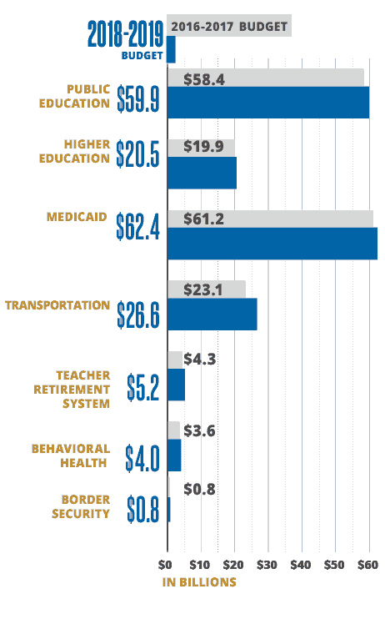
Aside from issuing yearly financial reports, Scurry area issues reviewed month to month monetary reports to upgrade budgetary straightforwardness (Scurry County, 2018).
Tax Rate
The successful rate is the aggregate tax rate expected to raise a similar measure of property impose income for Scurry County from similar properties in both past tax year and the present tax year. The figure 1 underneath shows Scurry County tax rate for the proposed property tax rate for the 2018 tax year.
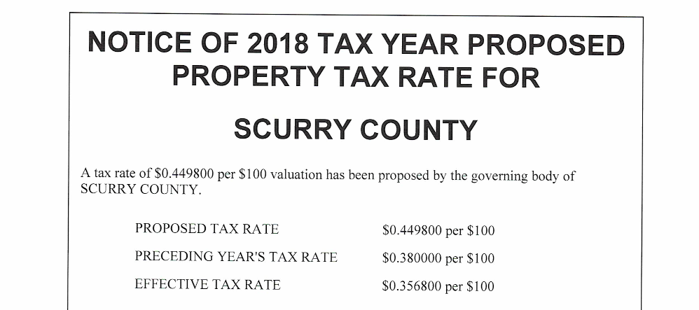
Source: Scurry County Tax Assessor-Collector
The combined sales tax rate for Scurry County, TX is 6.75%. This is the aggregate of state and province sales tax rates. The Texas state sales impose rate is at present 6.25%. The Scurry County sales tax rate is 0.5% (Avalara, 2018a).

Source: Avalara, 2018
b. Local Government
Scurry County has the following municipals: Snyder and Hermleigh; and other unincorporated communities, for example, Fluvanna, Dunn and Ira.
Snyder is a town in, and the county seat of Scurry County, Texas, United States. The population was 11,202 at the 2010 enumeration (Texas Gov, 2010). The city is situated in the lower some portion of the South-western Tablelands biological area.
The combined sales tax rate for Snyder, TX is 8.25%. This is the aggregate of state, municipal and city sales tax rates. The Texas state sales tax rate is right now 6.25%. The Scurry County sales tax rate is 0.5%. Snyder sales impose rate is 1.5% (Avalara, 2018b).
Hermleigh is a census-designated place (CDP) in Scurry County, Texas, United States. Hermleigh lies on U.S. Highway 84, ninety-six miles southeast of Lubbock, and has population of 345 individuals at the 2010 evaluation (Texas Gov, 2010). As of the statistics of 2000, there were 393 individuals, 151 families, and 104 families living in the CDP. The population thickness was 43.4 individuals per square mile (16.7/km²). There were 183 lodging units at a normal thickness of 20.2/sq mi (7.8/km²). The racial make-up of the CDP was 90.08% White, 2.29% African American, 0.25% Asian, 5.34% from different races, and 2.04% from at least two races. Hispanic or Latino of any race were 23.66% of the population.
Fluvanna is a unincorporated community in Scurry County, Texas, United States. It lies only south of the Llano Estacado high on the caprock, where Farm-to-Market Road 1269 and Ranch Road 612 meet.
Public Community, Technical, and State Colleges
The Texas Higher Education Coordinating Board (THECB) is in charge of scholastic and workforce programs at Texas people group, specialized, and state universities. The THECB teams up with other state organizations, for example, the Texas Workforce Commission, the Texas Education Agency, and the Texas Workforce Investment Council, to encourage and offer help for vocation and specialized instruction and workforce exercises (TCHEB, 2018).
Municipal Councils
Texas is divided into 24 municipals, each served by a voluntary association of local legislative elements that coordinate projects and administrations to address needs that cross jurisdictional limits (TARC, 2018).
Water Development
Groundwater is a noteworthy wellspring of water in Texas, giving around 60 percent of the 16.1 million acre-feet of water utilized in the state. The mission of the Groundwater Division is to gather, decipher, and give exact, target data on the groundwater assets of Texas. Our vision is for the general population of Texas to know and comprehend their groundwater assets.
The Groundwater Division is in charge of all parts of groundwater thinks about in the state. It screens groundwater levels and groundwater quality in 9 noteworthy and 22 minor aquifers, lead territorial scale groundwater demonstrating, and house and keep up water well records. It additionally surveys and endorses groundwater the management designs and take an interest in the foundation of wanted future states of aquifers in groundwater the board zones (TWDB, 2018).

References
Avalara. (2018a). Scurry County, Texas Sales Tax Rate. Retrieved from: https://www.avalara.com/taxrates/en/state-rates/texas/counties/scurry-county/
Avalara. (2018b). Snyder, Texas Sales Tax Rate. Retrieved from: https://www.avalara.com/taxrates/en/state-rates/texas/cities/snyder/?sessionId=1544435241533&referrer=https%3A%2F%2Fwww.google.com%2F&lastReferrer=www.avalara.com
Data USA. (2018). Scurry County , TX. Retrieved from: https://datausa.io/profile/geo/scurry-county-tx/
Leffler, J. (2018). Texas County. Tshaonline. Retrieved from: https://tshaonline.org/handbook/online/articles/hcs07
Minor, D. (2018). Scurry, TX. Tshaonline. Retrieved from: https://tshaonline.org/handbook/online/articles/hls33
Scurry County. (2017). Scurry County Financial Statement and Independent Auditor’s Report. Scurry County. Retrieved from: http://www.co.scurry.tx.us/upload/page/7106/docs/FINAL%20-%20Scurry%20County%20-%202017%20Financial%20Statements.pdf
Scurry County. (2018). Scurry County Texas. Retrieved from: http://www.co.scurry.tx.us/page/scurry.FinancialTransparency
TARC. (2018). Municipalal Councils. Texas Association of Municipalal Councils. Retrieved from: https://txmunicipalalcouncil.org/municipalal-councils/
TCHEB. (2018). Public Community, Technical, & State Colleges. Retrieved from: http://www.thecb.state.tx.us/index.cfm?objectid=EDCAFAF8-D542-11E7-A03300505694284C
Texas, Gov. (2010). 2010 Census: Population of Texas Cities, Arranged in Alphabetical Order. Retrieved from: https://www.tsl.texas.gov/ref/abouttx/popcity12010.html
TWDB. (2018). Ground Water. Texas Water Development Board. Retrieved from: http://www.twdb.texas.gov/groundwater/index.asp

